Insert title here (max. 2 lines)
SURNAME, Presenter name¹, SURNAME, Author name², SURNAME, Senior name¹.
(presenter name underlined). Do not abbreviate 1st and last name.
¹Filiation, UFXX, City, Country;
²Filiation, UFXX, City, Country.
presenter@youremail.com; senior@youremail.com (presenter and senior e-mail)
Keywords: xxx, xxx, xxx.
Abstract
Your abstract here. Do not exceed 250 words. Authors can also include a graphical abstract. Example as follows:

BACKGROUND: Briefly describe the background and the rationale for the study as well as the aim of the research or the hypothesis being tested. METHODS: Provide a precise description of the experimental procedures, techniques applied, and statistical analyses performed. Any necessary references should be cited within the text. Specify the Human or Animal Research Ethics Committee approval number when applicable.
RESULTS: Present the findings in a clear and concise manner, including statistical significance where relevant. CONCLUSIONS: Summarize and interpret the main findings, highlighting their relevance and implications.

Graphical Abstract
Your graphical abstract here. Further instructions on graphical abstract composition, we recommend reading https://www.elsevier.com/authors/journal-authors/graphical-abstract. Example as follows:
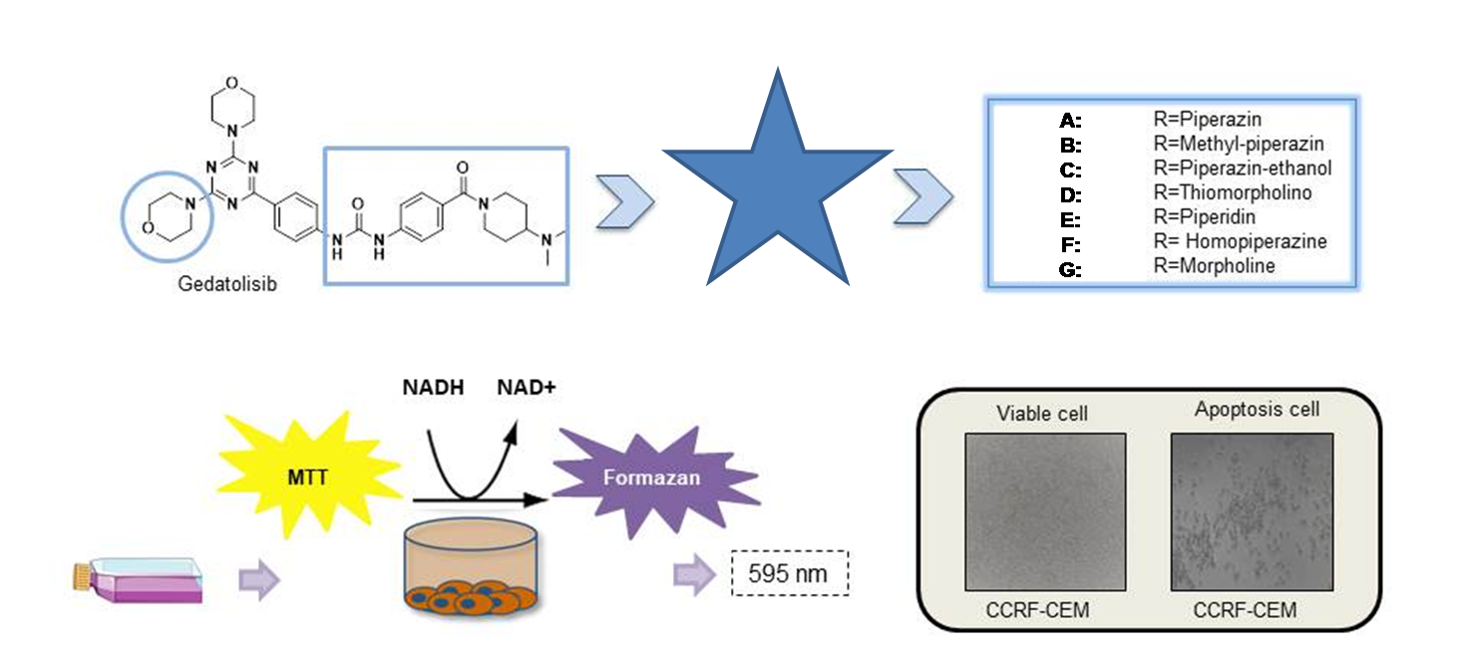
Acknowledgments
CAPES, CNPq etc.

